TASK – 5
(1) Same Account and Same Region:
Steps:
1. Create a VPC.
VPC - 150.10.0.0/18
2. Create a subnet based on VPC.
i) public subnet – for access internet
ii) private subnet – for storing private data (not accessible over internet)

VPC-1
(i) - Public subnet:
Name - public-subnet
Public IP - 3.110.194.143

(ii) - Private subnet:
Name - public-subnet
Private IP - 170.50.0.19

VPC-2
(i) - Private subnet:
Name - public-subnet
Private IP - 170.50.0.26

Delete way:
1. peering connection -> Route table entries
2. vpc -> subnets -> Route table
3. Route table (if created by user).

Error:- If it went blachole, becoz you didnot accepted the peer connection request.

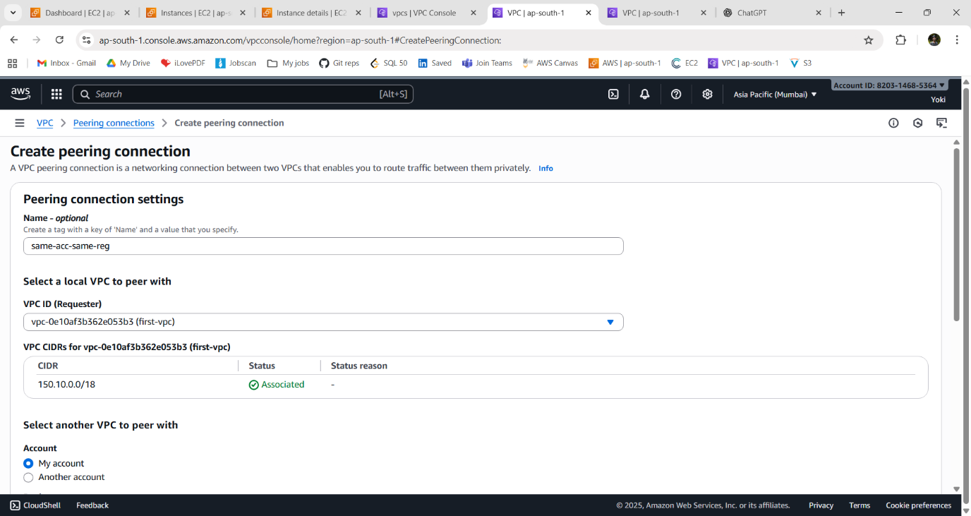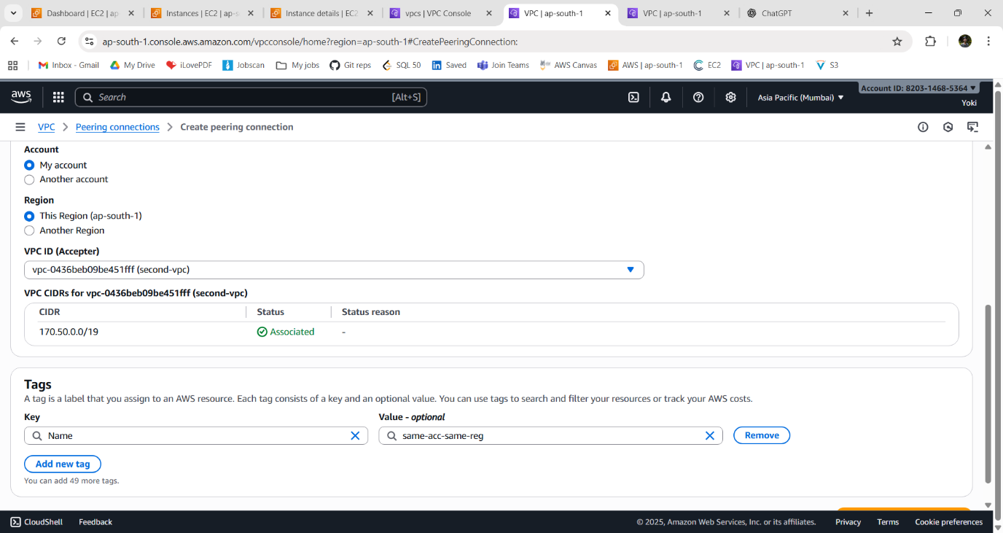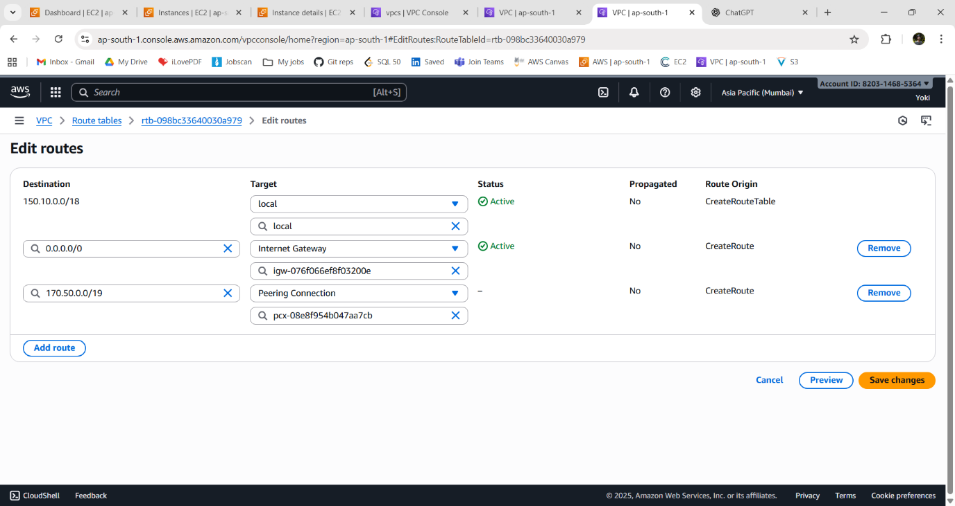
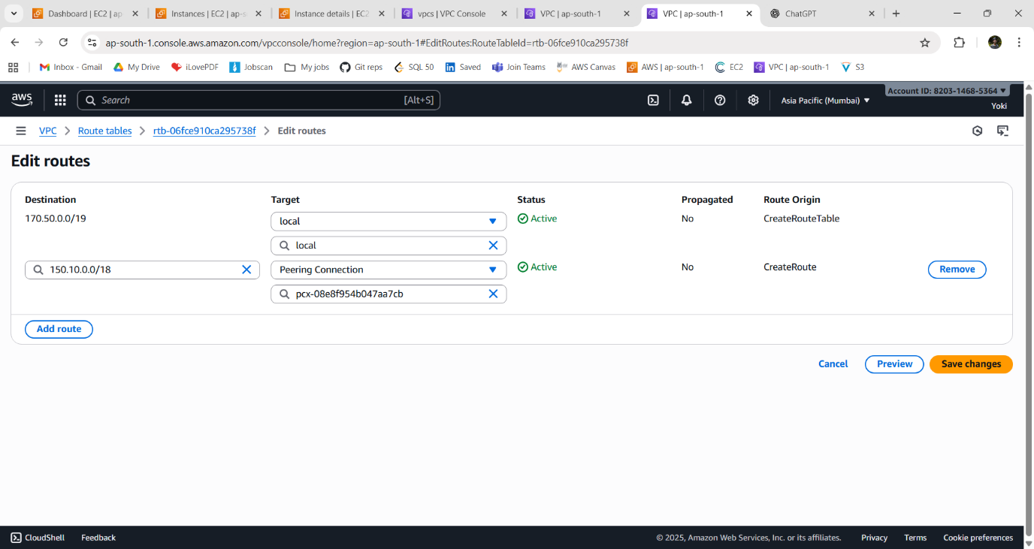

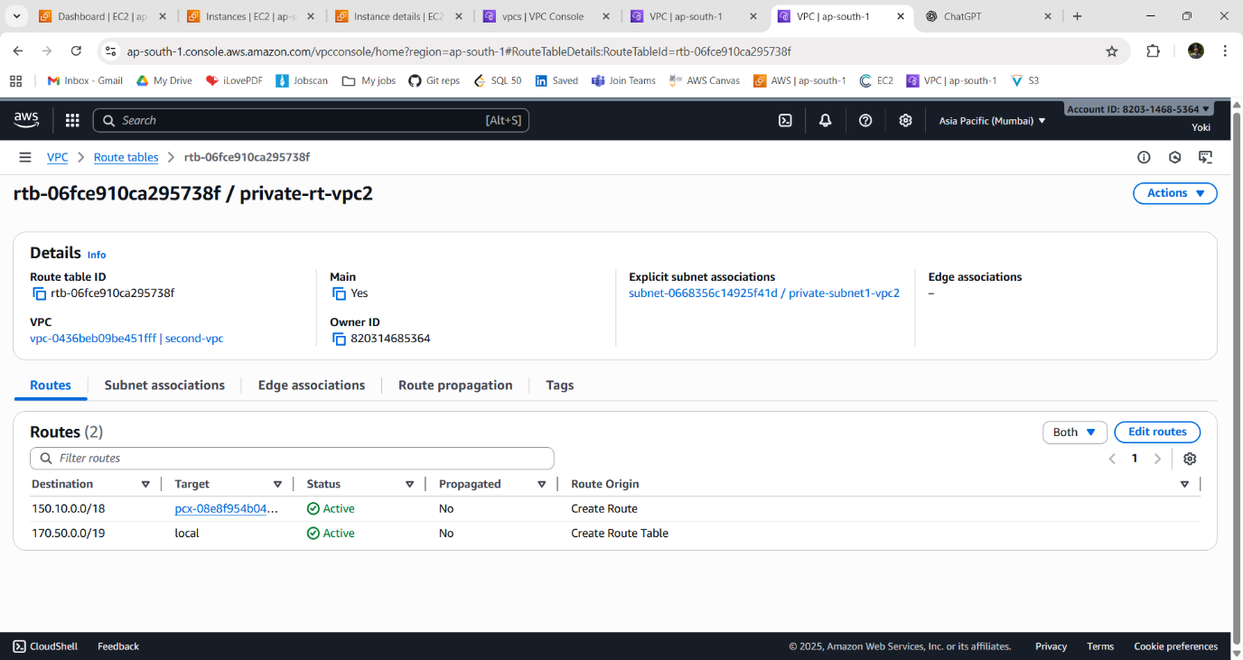
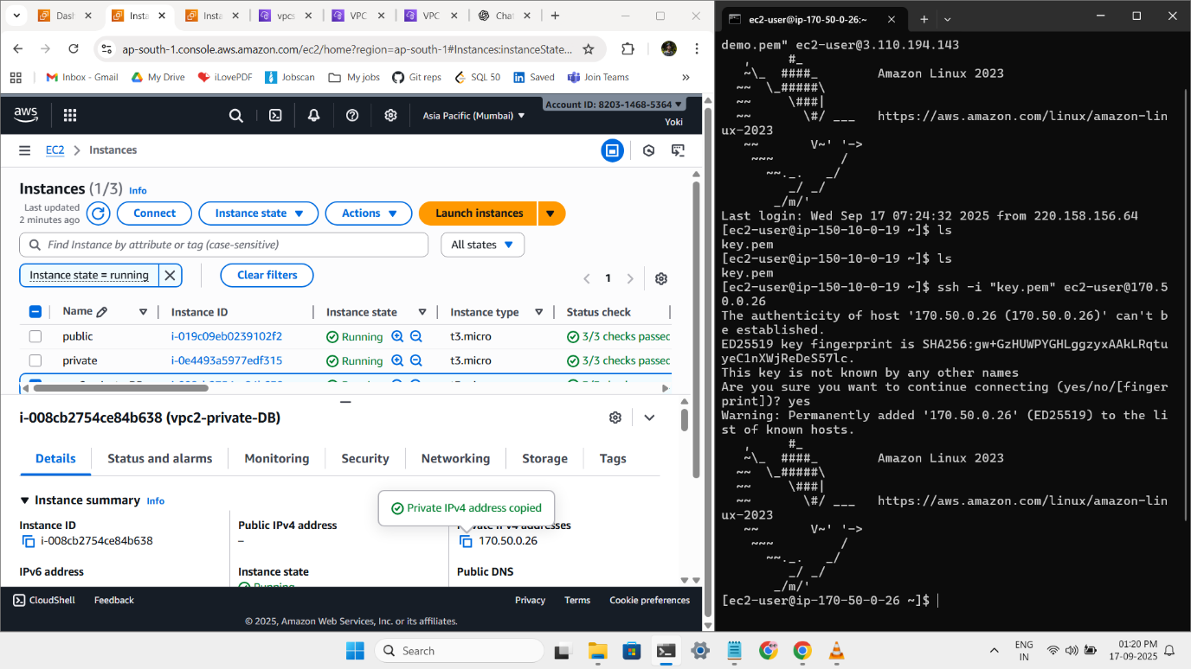
(2) Same Account and Different Region:
Steps:
1. Create a VPC.
VPC - 150.10.0.0/18
2. Create a subnet based on VPC.
i) public subnet – for access internet
ii) private subnet – for storing private data (not accessible over internet)

VPC-1
(i) - Public subnet:
Name - public-subnet
Public IP - 3.110.194.143

(ii) - Private subnet:
Name - public-subnet
Private IP - 170.50.0.19

Create a VPC in another region (North Virginia us-east)
VPC-2
(i) - Private subnet:
Name - public-subnet
Private IP - 170.50.0.26

Delete way:
1. peering connection -> Route table entries
2. vpc -> subnets -> Route table
3. Route table (if created by user).

Error:-
If it went blachole, becoz you didnot accepted the peer connection request.
